int *testptr = NULL; // DECL // DEF
printf ( "values are %p, %d, %p", testptr , *testptr , &testptr);

https://leetcode.com/problems/find-all-numbers-disappeared-in-an-array/

// int findMissing(int a[], int size) // ALSO WORKS
int findMissing(int* a, int size)
{ int i;
for(i = 0; i < size; i++)
{ int val = a[i]-1;
if(a[val] > 0)
a[val]*=-1;
}

for(i=0; i < size; i++)
{ if(a[i] > 0)
printf("%d, ", i+1);
}
return 0;
}
https://www.geeksforgeeks.org/find-missing-elements-from-an-array/
https://www.youtube.com/watch?v=re7fhVyKWZI
https://www.youtube.com/watch?v=jSfDPVIYe1s

https://leetcode.com/problems/intersection-of-two-linked-lists/
Method 1: Using difference of node counts (EASIER TO UNDERSTAND, LENGTHY)
- Get count of the nodes in the first list, let count be c1.
- Get count of the nodes in the second list, let count be c2.
- Get the difference of counts d = abs(c1 – c2)
- Now traverse the bigger list from the first node till d nodes so that from here onwards both the lists have equal no of nodes
- Then we can traverse both the lists in parallel till we come across a common node. (Note that getting a common node is done by comparing the address of the nodes)
Method 2: Two Pointers (SIMPLER, OPTIMIZED, COMPACT)
- Each pointer points to the start of the list, pA and pB
- When pA reach the end, we reinitialize to head of B, opposite thing happens for pB
- If the end of list for A and B is not the same, we have no intersection
- Otherwise, they will eventually meet
ListNode *getIntersectionNode(ListNode *headA, ListNode *headB)
{ ListNode *a = headA, *b = headB;
while (a != b)
{ a = !a ? headB : a->next;
b = !b ? headA : b->next;
}
return a;
}
https://www.geeksforgeeks.org/write-a-function-to-get-the-intersection-point-of-two-linked-lists/
https://dev.to/seanpgallivan/solution-intersection-of-two-linked-lists-478e
https://just4once.gitbooks.io/leetcode-notes/content/leetcode/linked-list/160-intersection-of-two-linked-lists.html

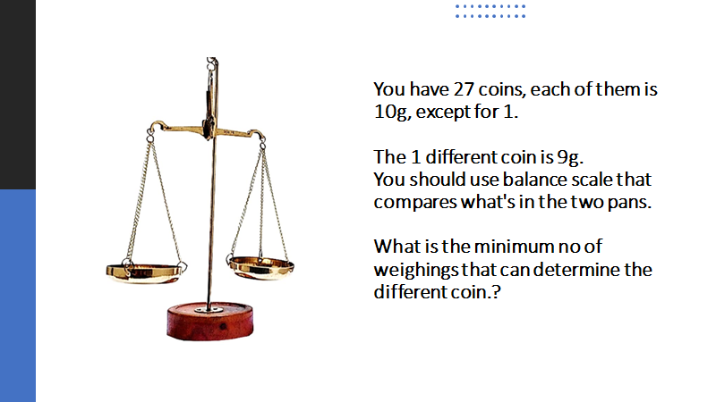

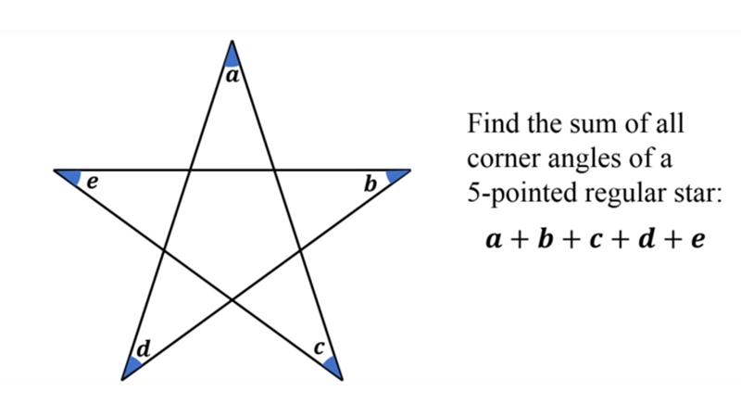

180 -2f = e

a + b + c + d+ e = 5(180-2f)

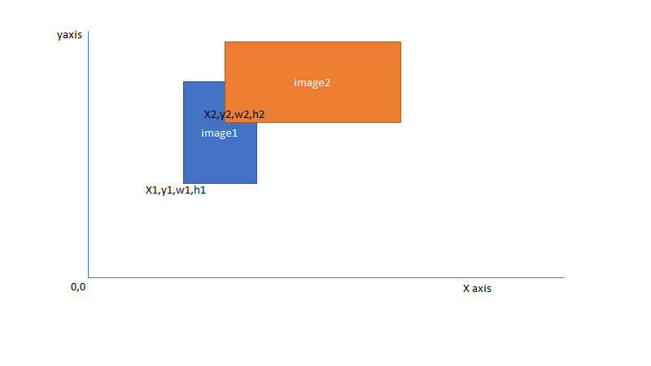

X1 xx1 = x1 + w1
Y1 yy1 = y1 + h1

X2 xx2 = x2 + w2
Y2 yy2 = y2 + h2

X3

//X2 < xx1 && Y2 < yy2 && X1 < X2 && Y1 < Y2

